**Step 1: Create S3 Buckets**

1. Create Source Bucket:

* Click “Create bucket” and follow the prompts to create a new S3 bucket. This will be your source bucket containing the CSV files.

2. Create Target Bucket:

* Similarly, create another S3 bucket that will serve as the target for your transformed data.

3. Create Athena Bucket to Store results :

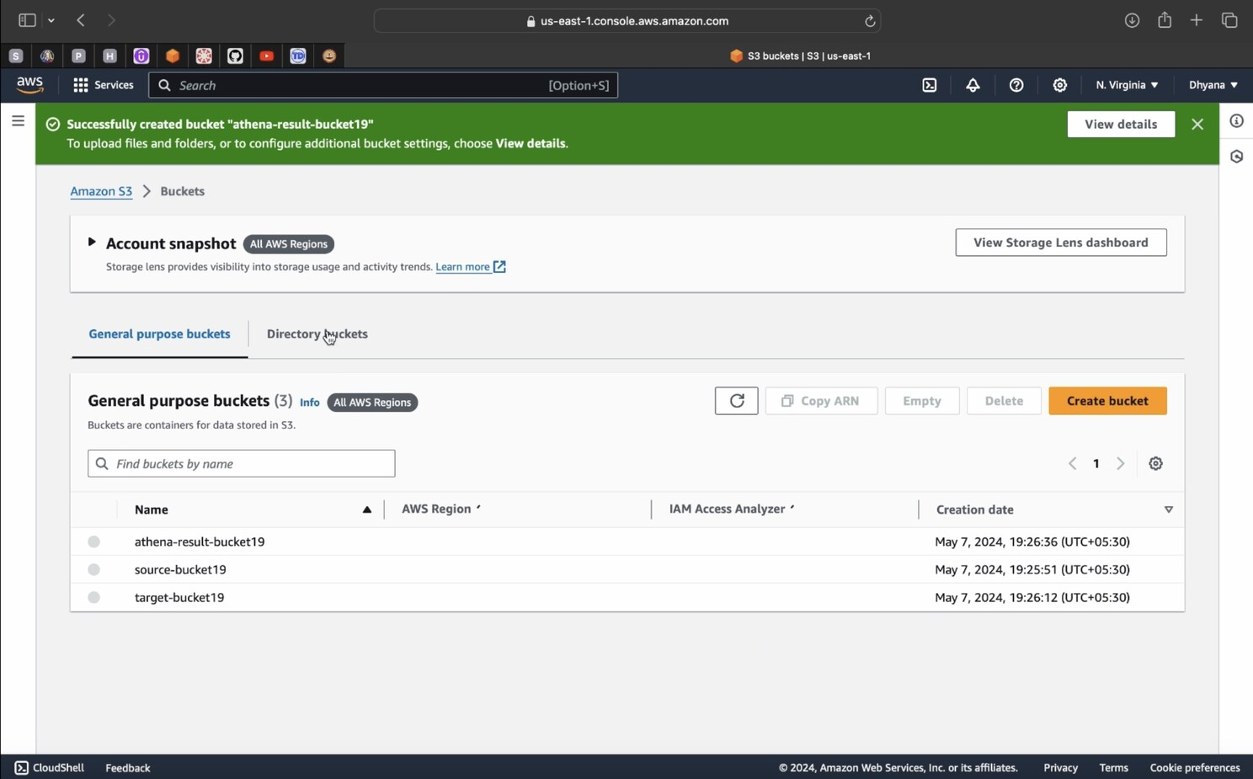

**Step 2: Create IAM Role for AWS Glue**

1. Choose a use case,” select “Glue.”
2. Attach Permissions Policies
3. Search and attach the policies:

* Search for and attach the policy AmazonS3FullAccess
* Search for and attach the policy AWSGlueServiceRole

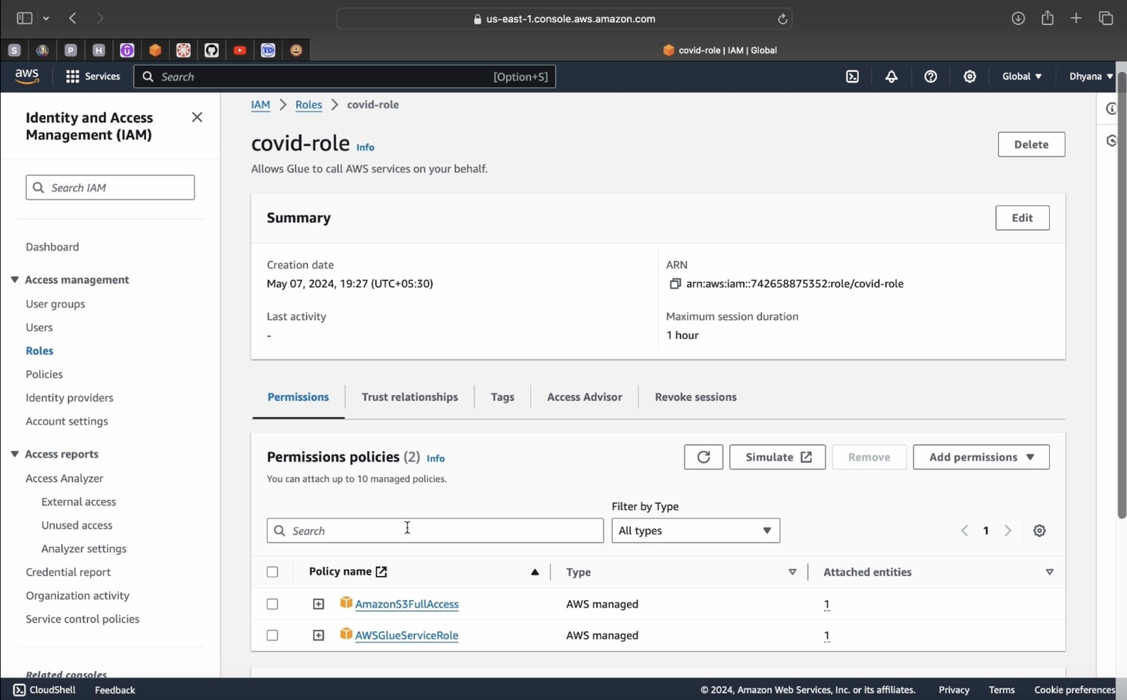

**Step 3: Upload CSV Files to Source Bucket**

* Upload the CSV files that you want to process into the source S3 bucket.Note(Create a folder inside the Bucket and then upload CSV file inside that folder because sometimes when you tried to run the query from Athena you might be getting RETURNS ZERO RECORDS)

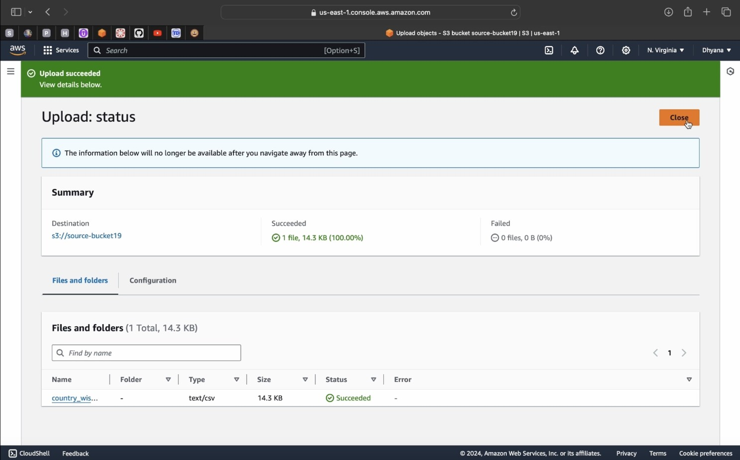

**Step 4: Set Up AWS Glue Crawler**

1. Go to AWS Glue Console
2. Go to Crawlers -> Create a Crawler
3. Click “Add crawler” and follow the wizard to configure the crawler
4. Specify a name for the crawler.
5. Choose “S3” as the data store.
6. Specify the S3 path to your source bucket.
7. Finish the wizard to create the crawler.

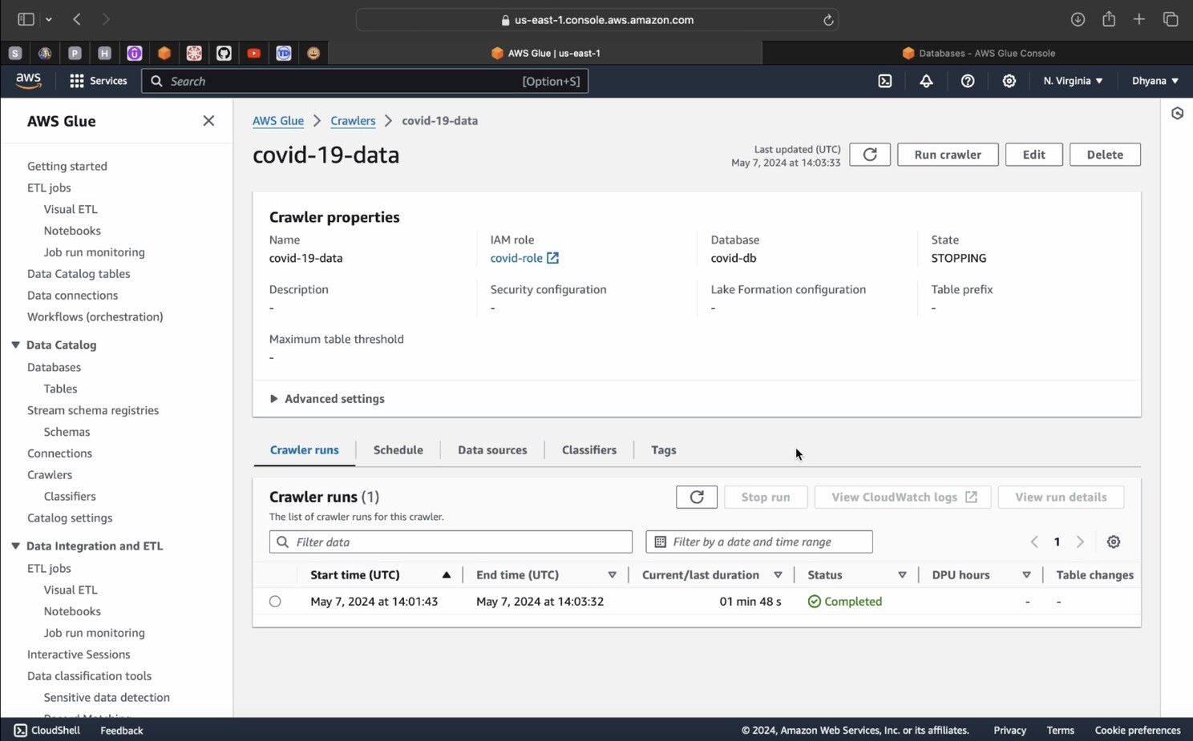

Status is now completed

Again go inside database there will be tables

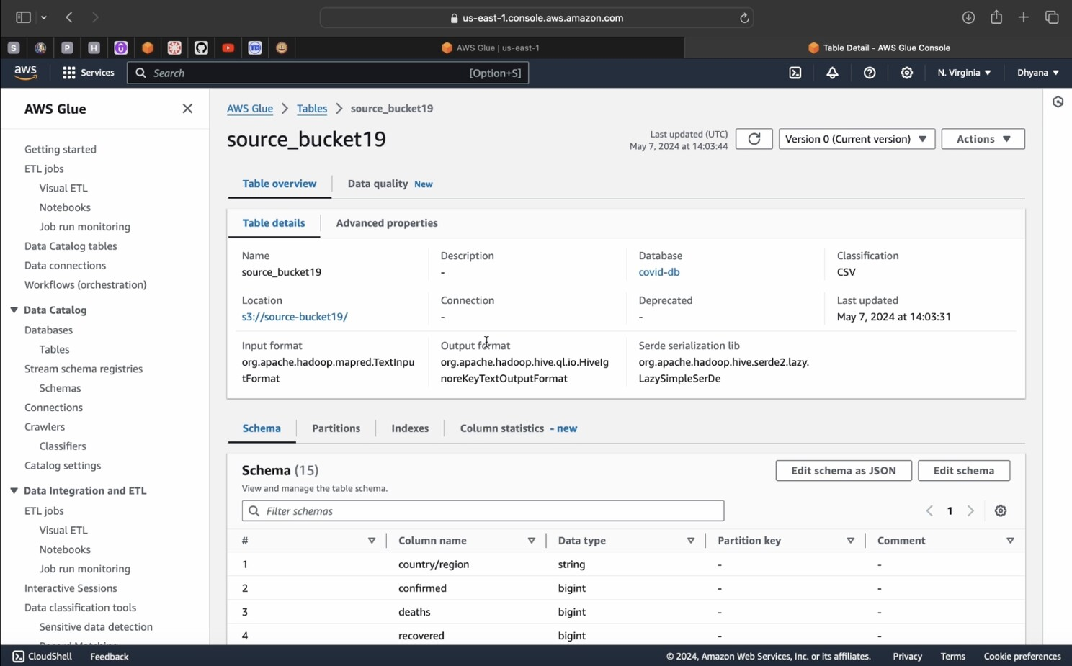

**Step 5: Create an ETL Job in AWS Glue**

1. Go to AWS Glue Console:

* Click on “Jobs” in the left sidebar.
* Click “Add job” and follow the wizard to configure the ETL job:
* Specify a name for the job.
* Choose the source and target connections.
* Define the transformation logic using the Glue ETL script.
* Finish the wizard to create the job.

1. Run the ETL Job:

* After creating the job, run it to perform the ETL process on the data.

2. Select Source bucket — Amazon S3 with customer — data catalog table

3.Select Target bucket — Select field

4.Select Transform bucket — Amazon S3 with customer id

5.Before Run Goto Job details

6.Set the Name of the job and also select the IAM role -> Then save

7.-> Run

8.Goto Runs Section -> once status succeeded

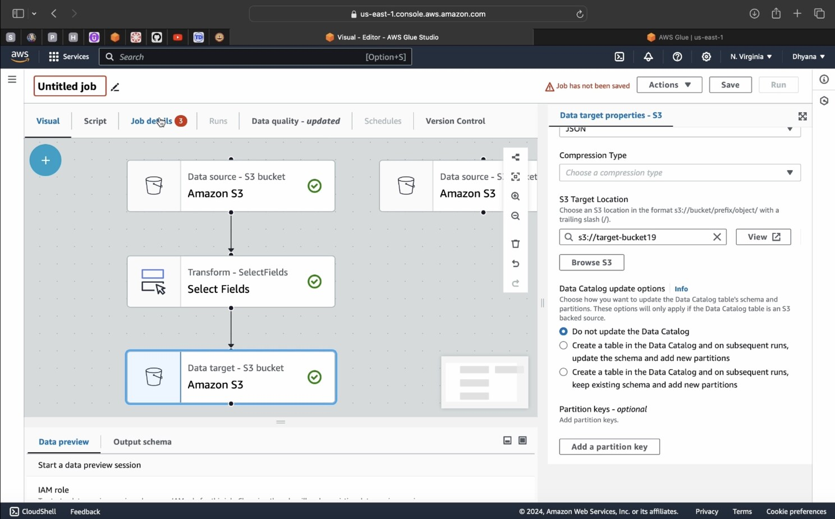

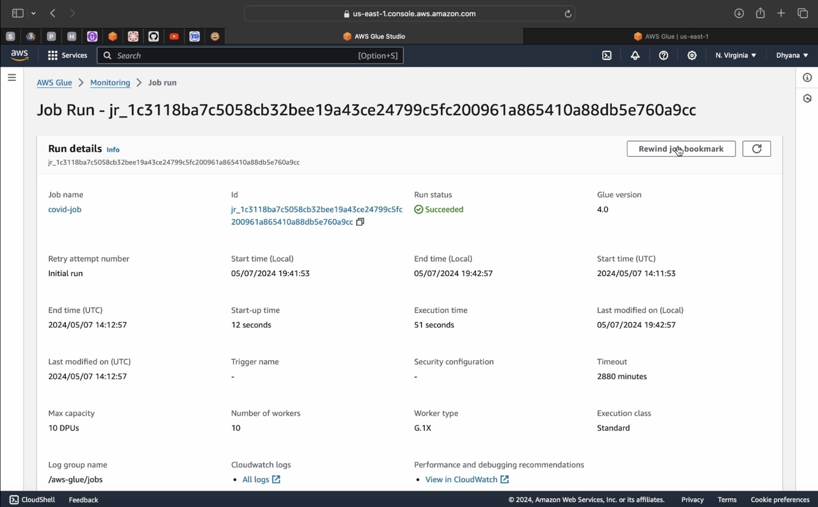

**Step 6: Check Transformed Data in Target Bucket**

* Verify that the transformed data is successfully loaded into the target S3 bucket.
* Goto yout target Bucket check your file will automatically added.

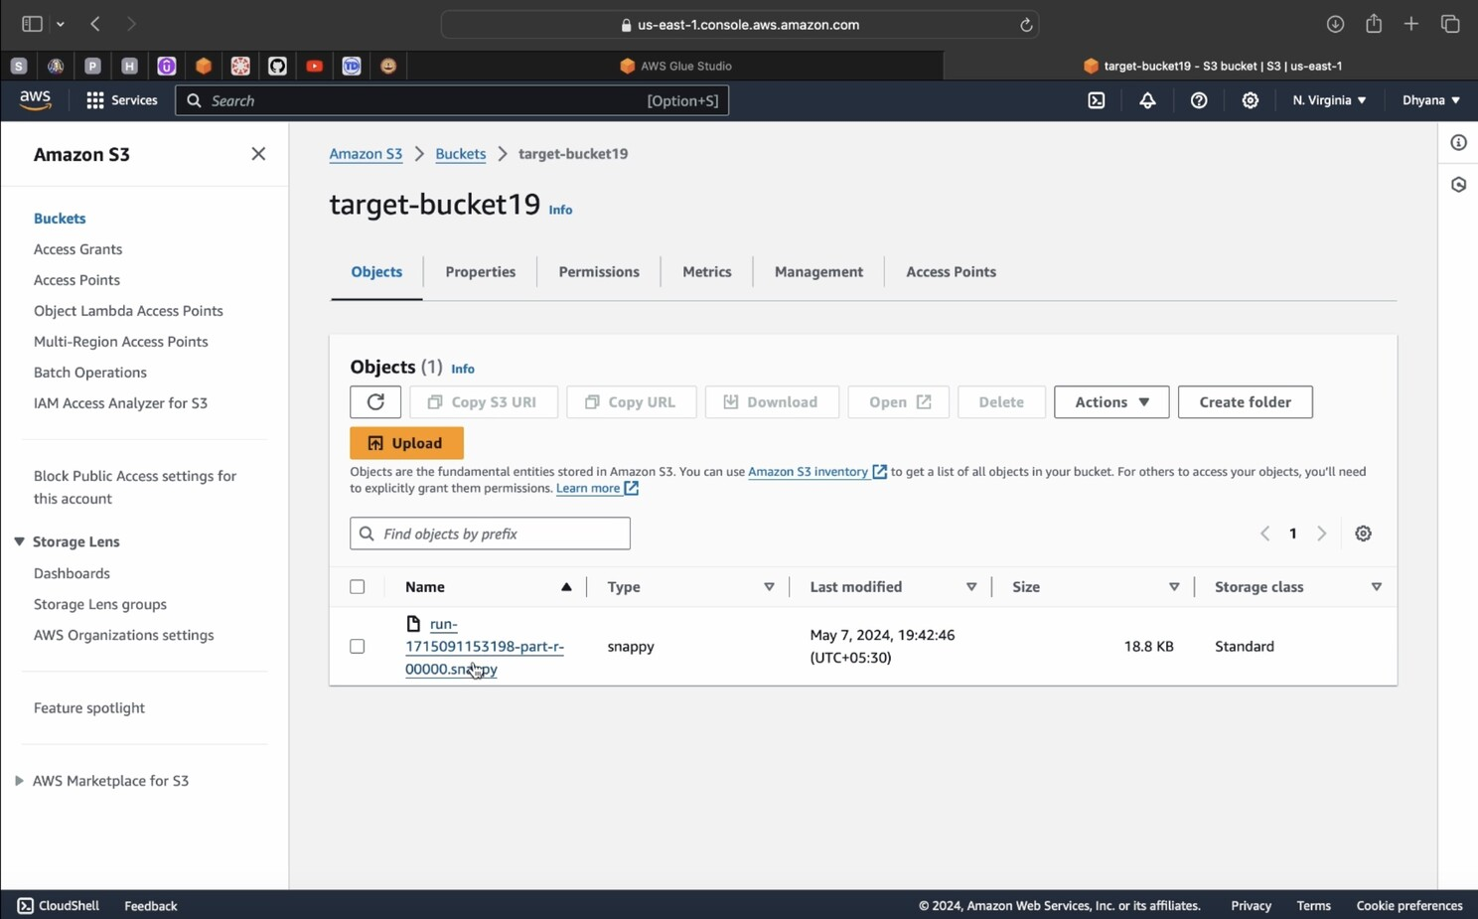

**Step 7: Set Up Amazon Athena**

Now you can directly Query here also using Athena

Action -> View data

Initially Query will not run so,

Goto Setting -> Manage

-> Browse S3 Bucket(Select the Athena Bucket)

-> Save

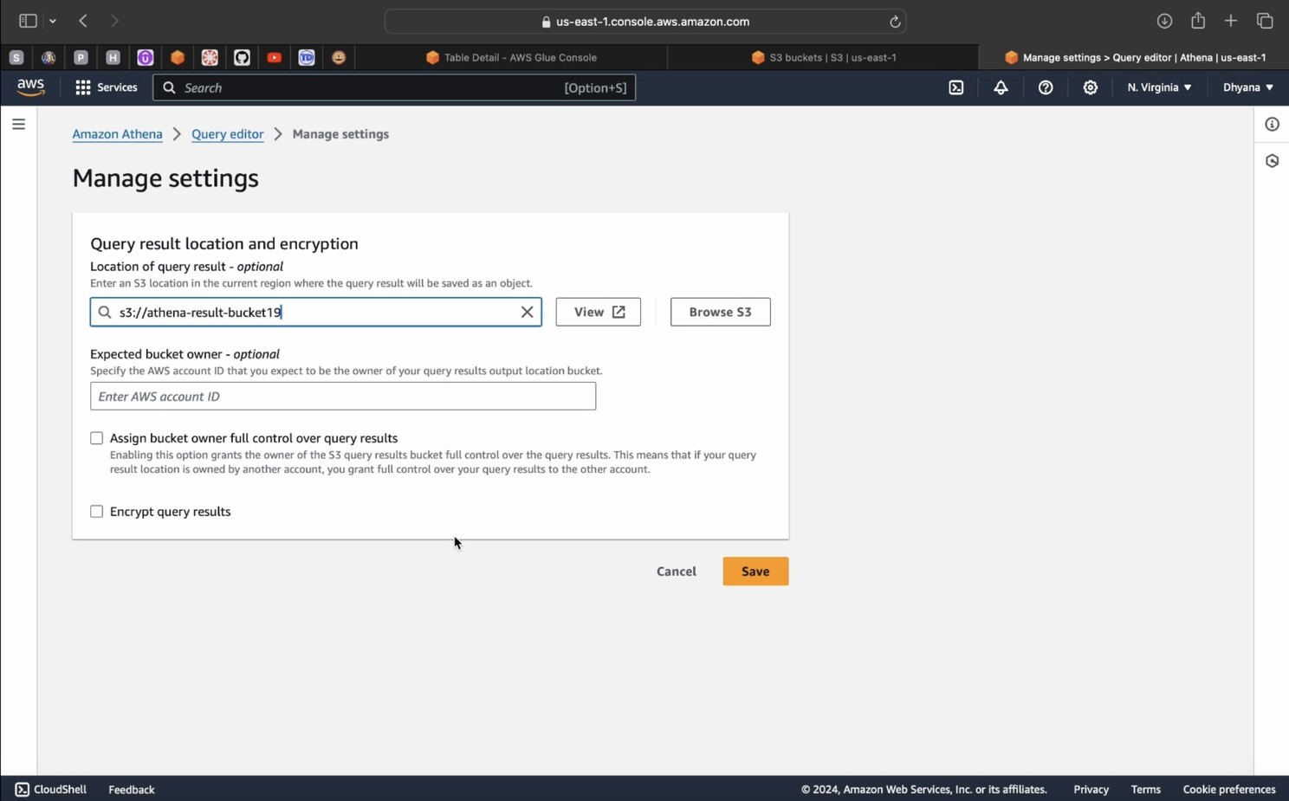

**Step 8: Run Queries in Athena**

* Use the Athena query editor to run SQL queries on your cataloged tables and analyze the transformed data.

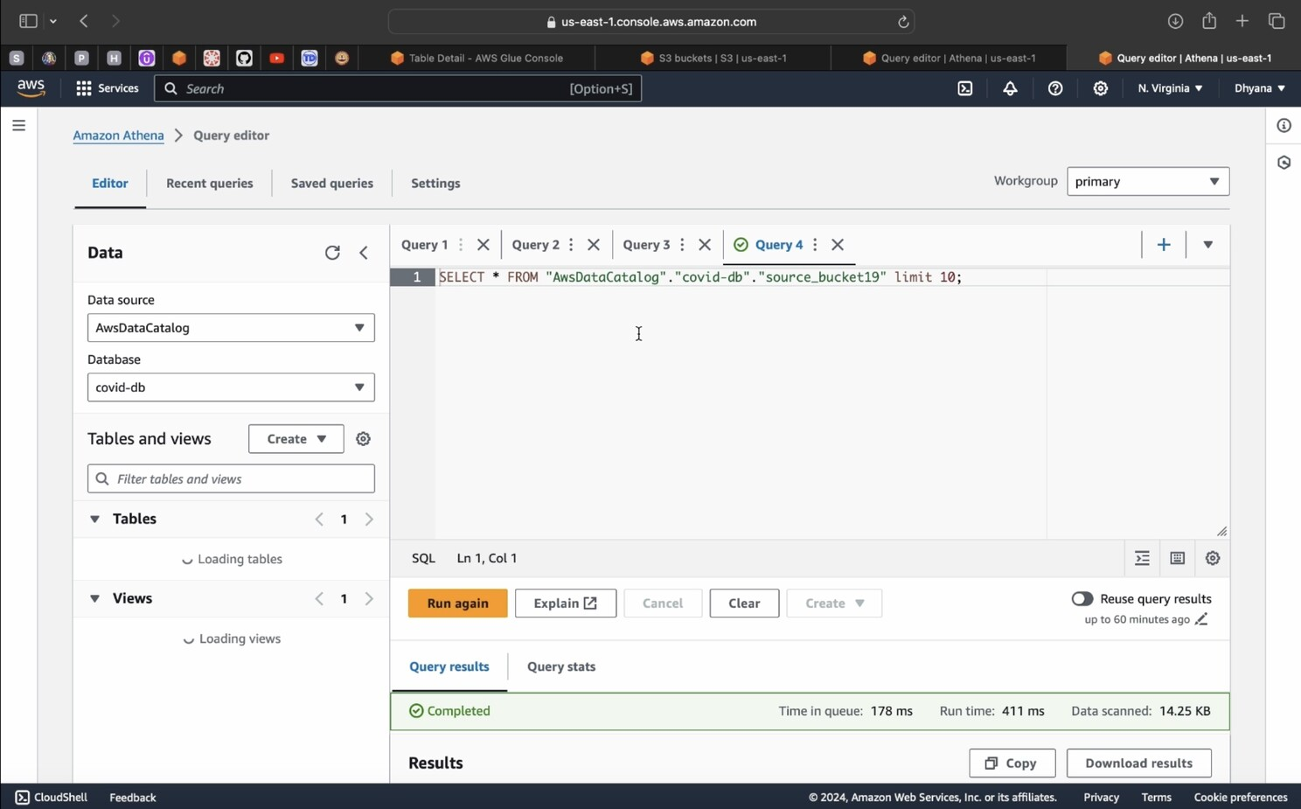

* As per your requirement give the query it will show you the tables.

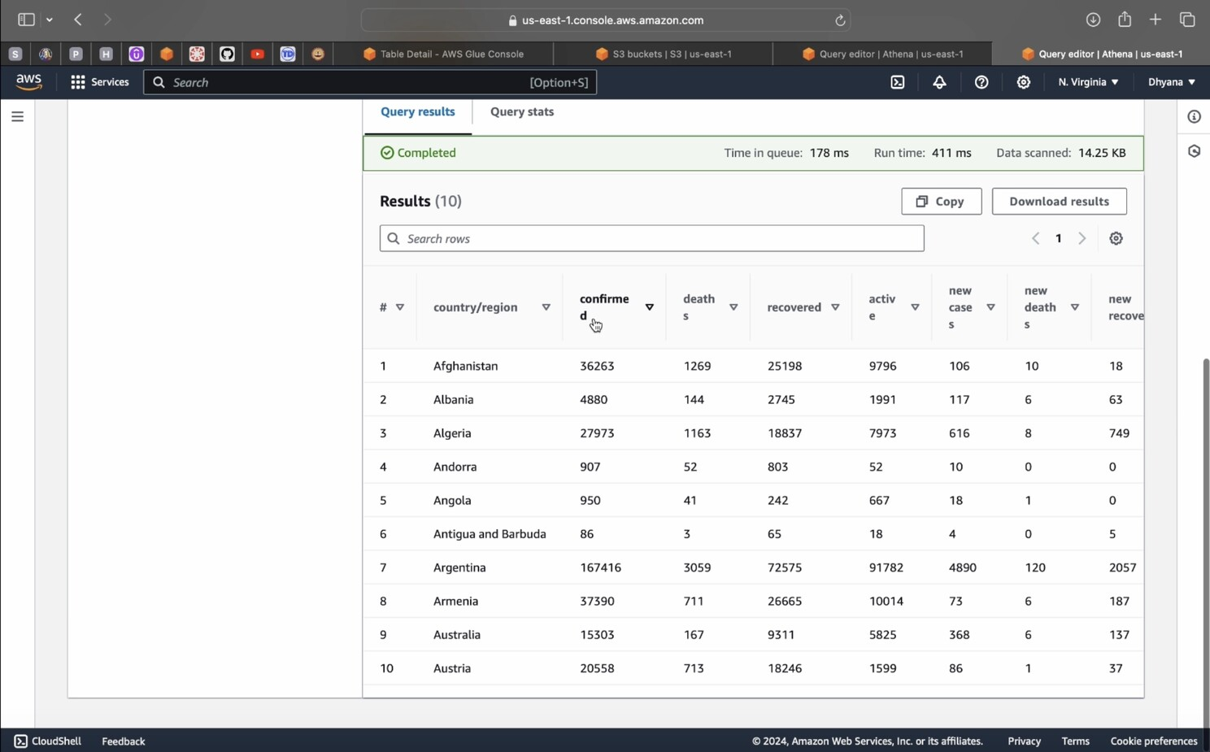

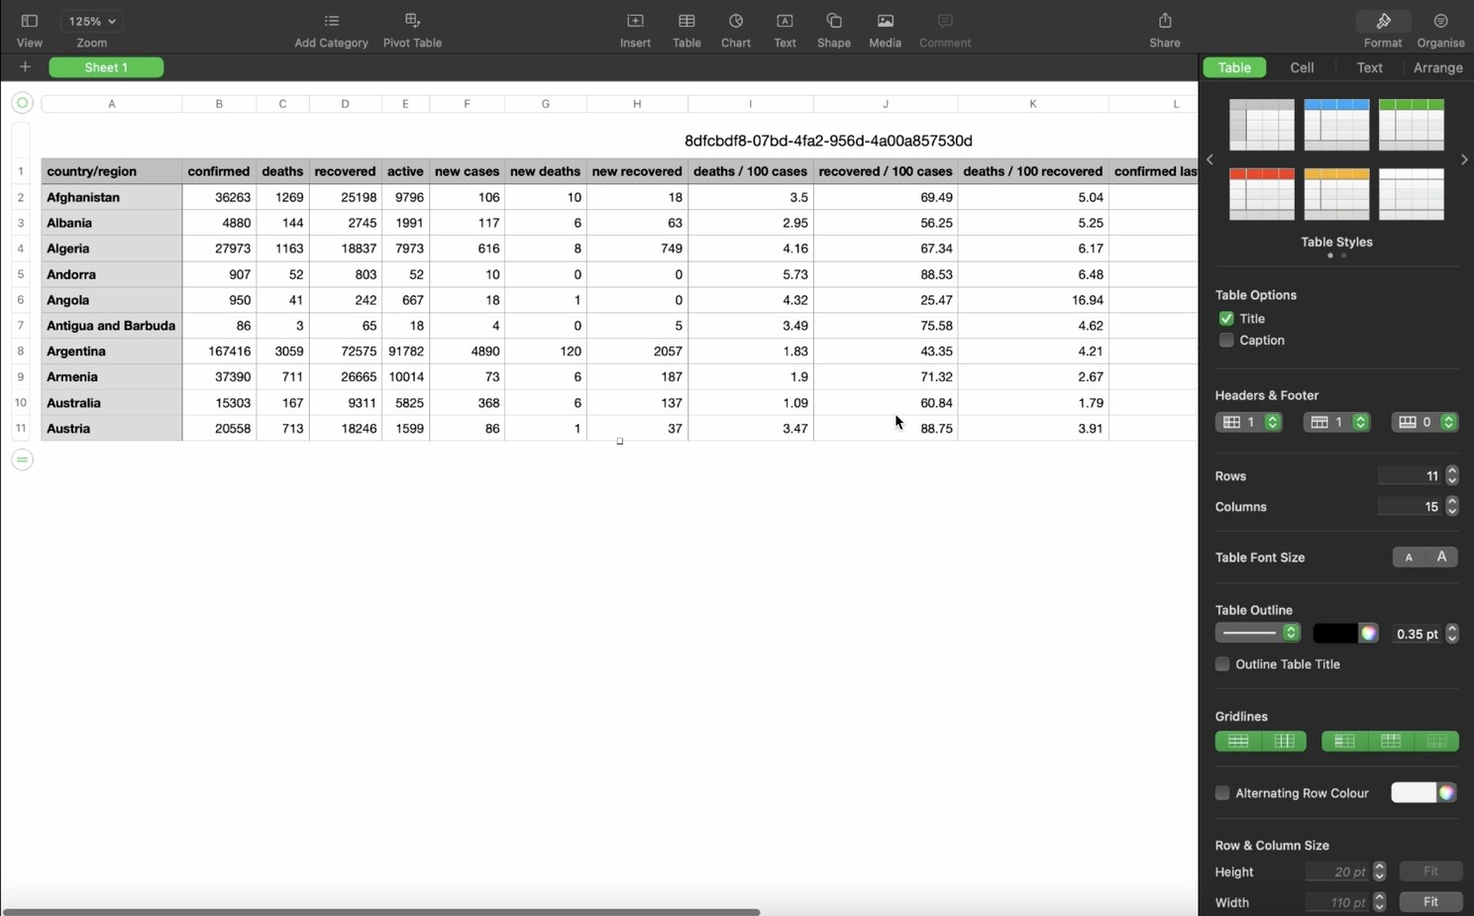

In this guide, we’ve traversed the intricacies of constructing a seamless data transformation process, from sourcing CSV files in an S3 bucket through Glue Crawlers, to transforming and loading the data into a designated S3 target bucket.